KT Things to Modify:
0. Add a Login Screen
- Change the money from US dollars ($) to Ringgit (RM).
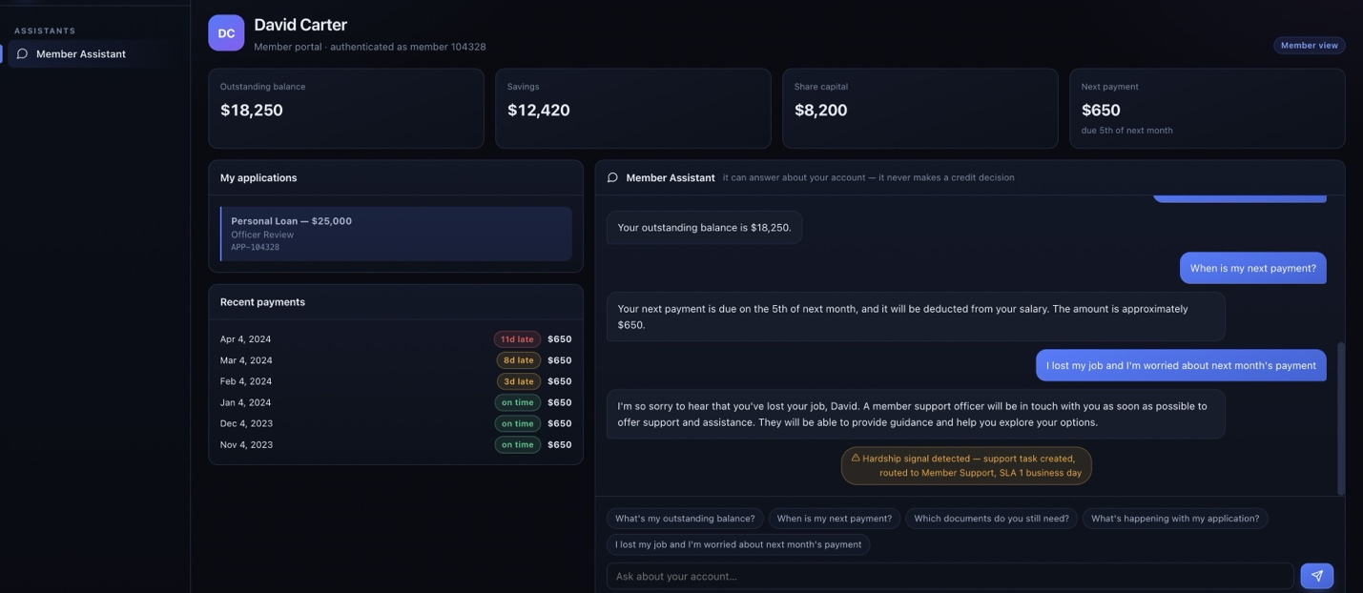

- Members, employers and branches are from another country- KT's members are Armed Forces personnel, MINDEF civil servants and retirees, paid monthly, with repayments taken from salary. The panel needs to see their own members on screen.
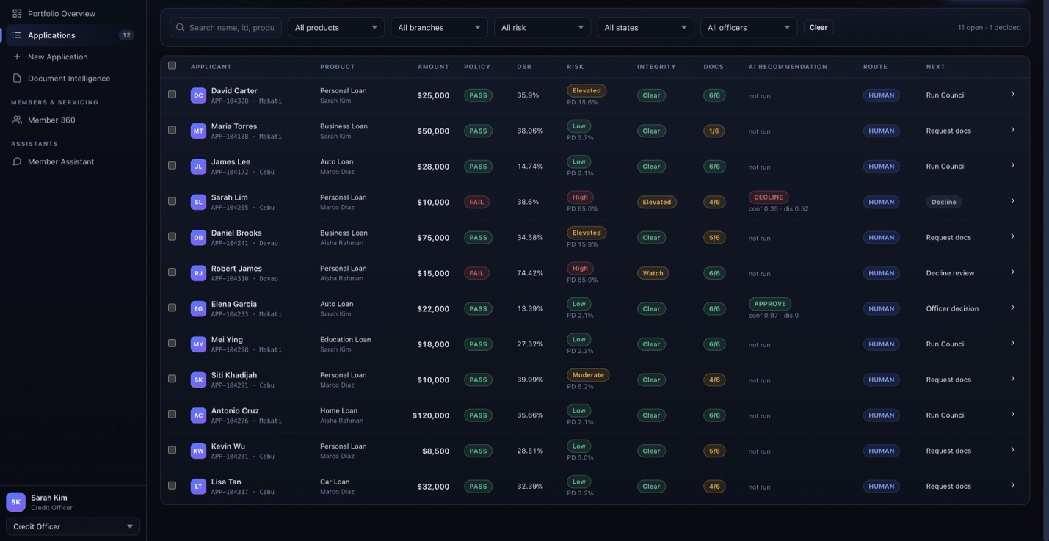

Products are not KT's, and the wording is conventional banking – Change everywhere
KT runs Islamic financing. Its website lists
Personal Financing ,
Express Financing,
Fees Financing ,
SME Financing,
Term Financing-I,
Contract Financing,
Motor Takaful,
General Takaful,
Ar-RahnuKT,
Also Change: Use KT's product names, "financing" instead of "loan", and "profit rate" instead of "interest rate".
- Change: Shift all synthetic dates into 2026, set "today" to the demo day, and want to make sure all the date/time are in Malaysia time (UTC+8) .

- The extracted fields in the document intelligence is not pointing to the right area in the document.
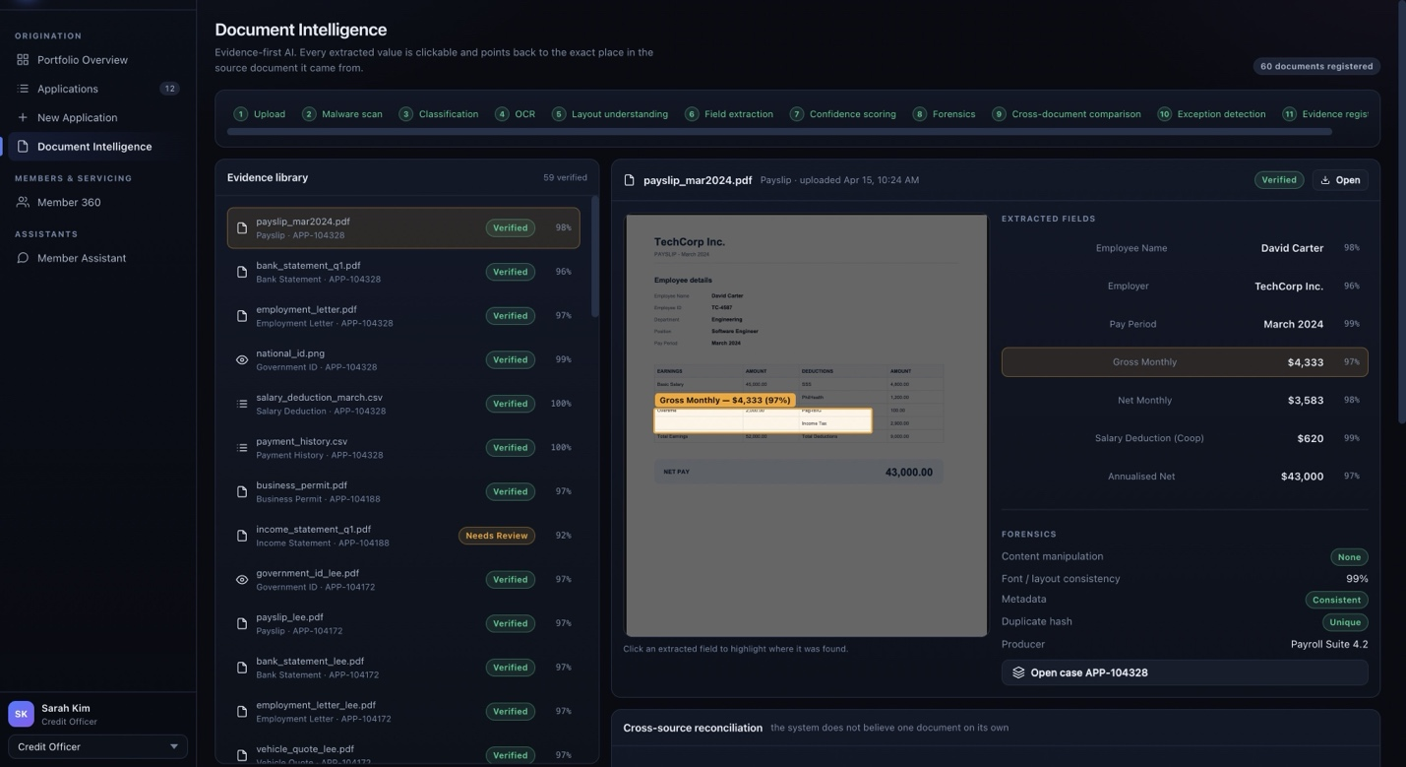

- On Robert James's case, "Maximum supportable financing" shows $-200, and "What changes the outcome" says "Requested amount reduced to about $-200". Link : https://spark-079e.tail1917c3.ts.net/#workbench/APP-104310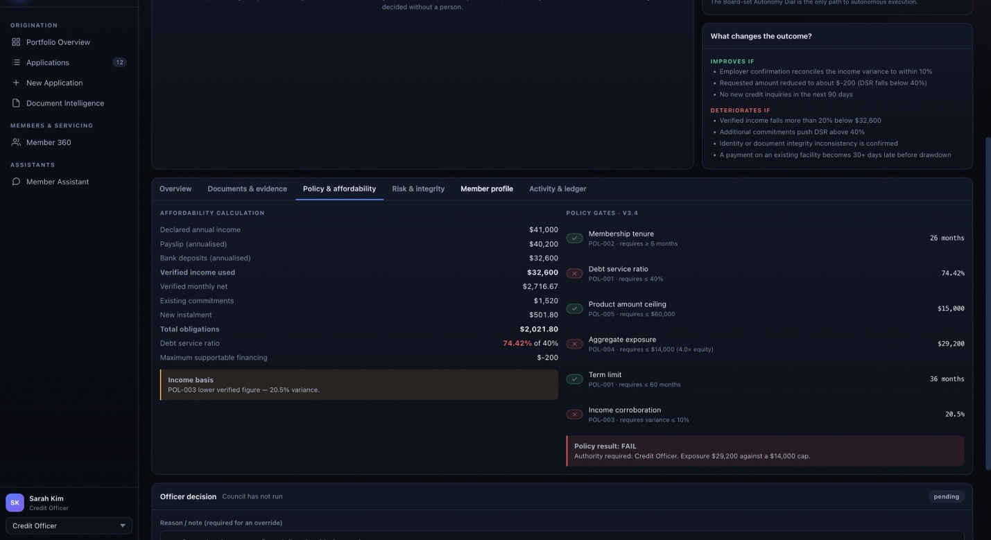

Malay answers are weak and sometimes wrong
Asked "Berapa baki pinjaman saya dan bila bayaran seterusnya?" (what is my balance and when is my next payment?), the assistant said the balance "cannot be seen in real time", though $18,250 is on the same screen. Replies use Indonesian words ("Anda", "kabar", "Asisten Kebijakan", "karena") rather than Malaysian Malay.
The AI model in use is a very small one ("llama3.2:3b", 3 billion parameters). A larger model ("qwen3:30b") is already installed, can we try with that?

But when we initiate the conversation in English, the replies are better
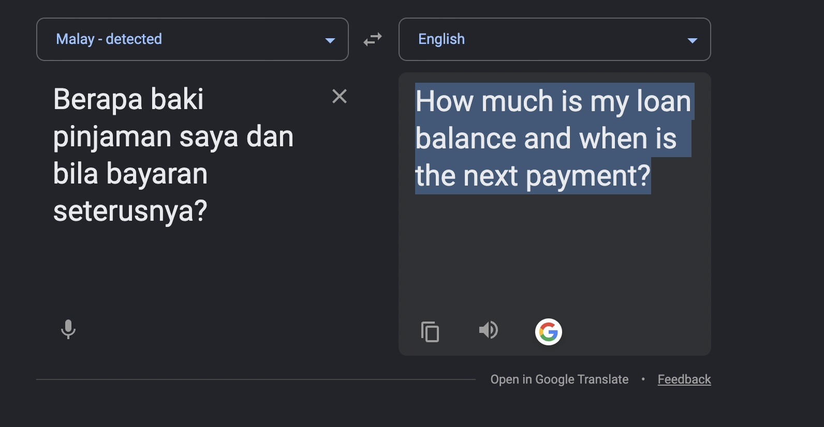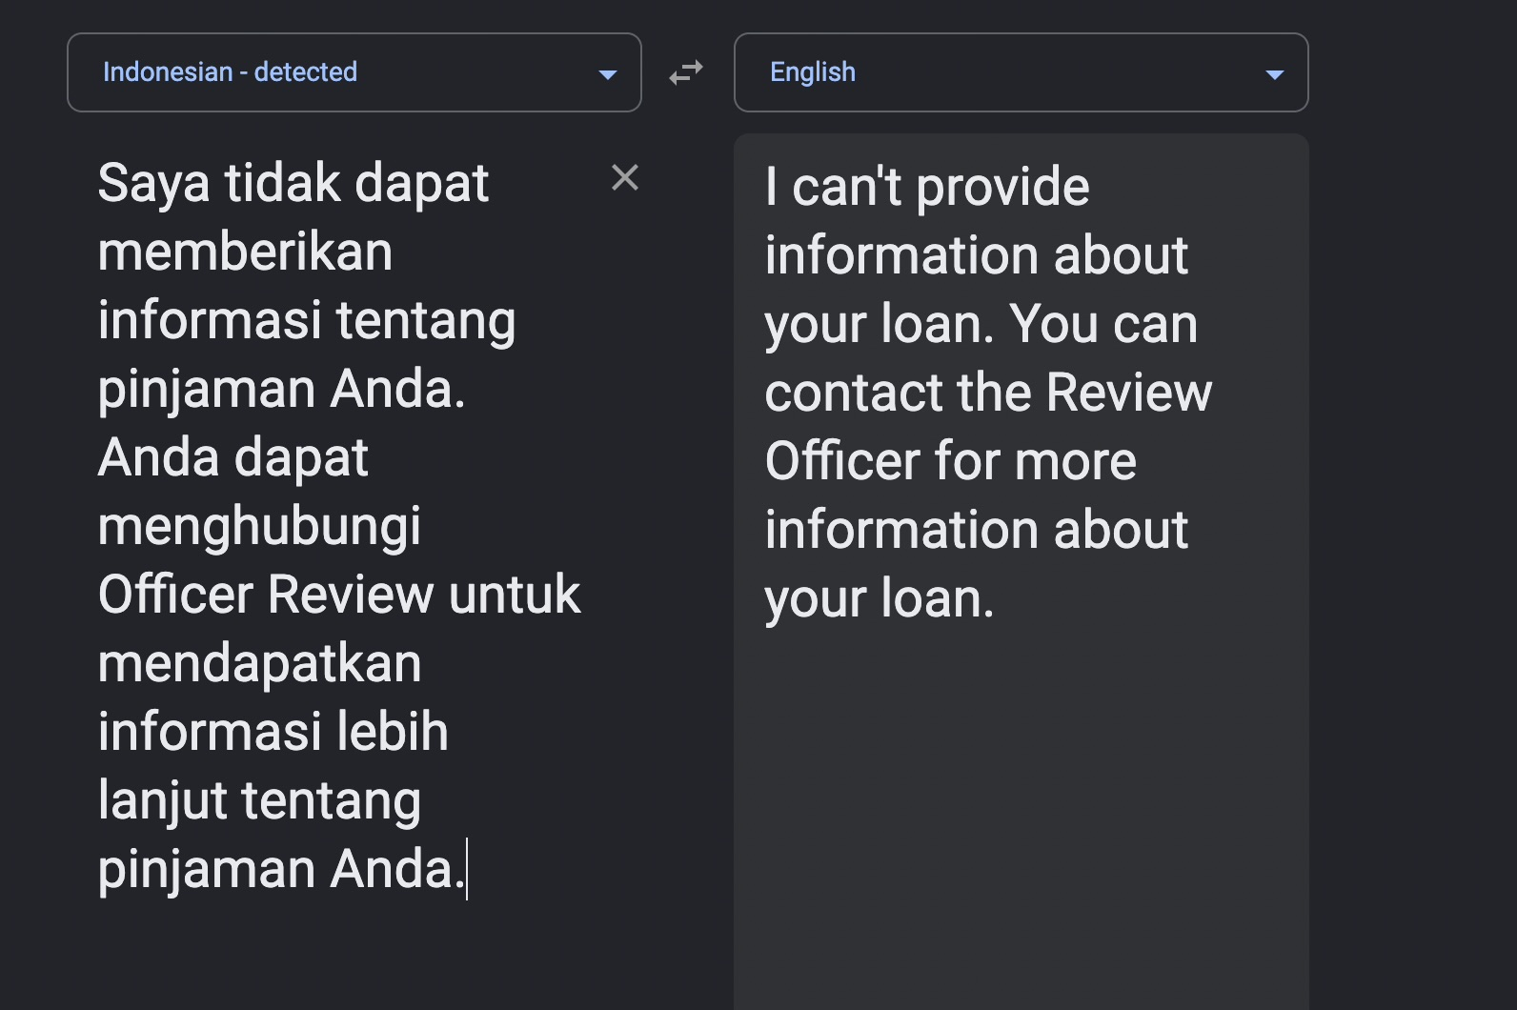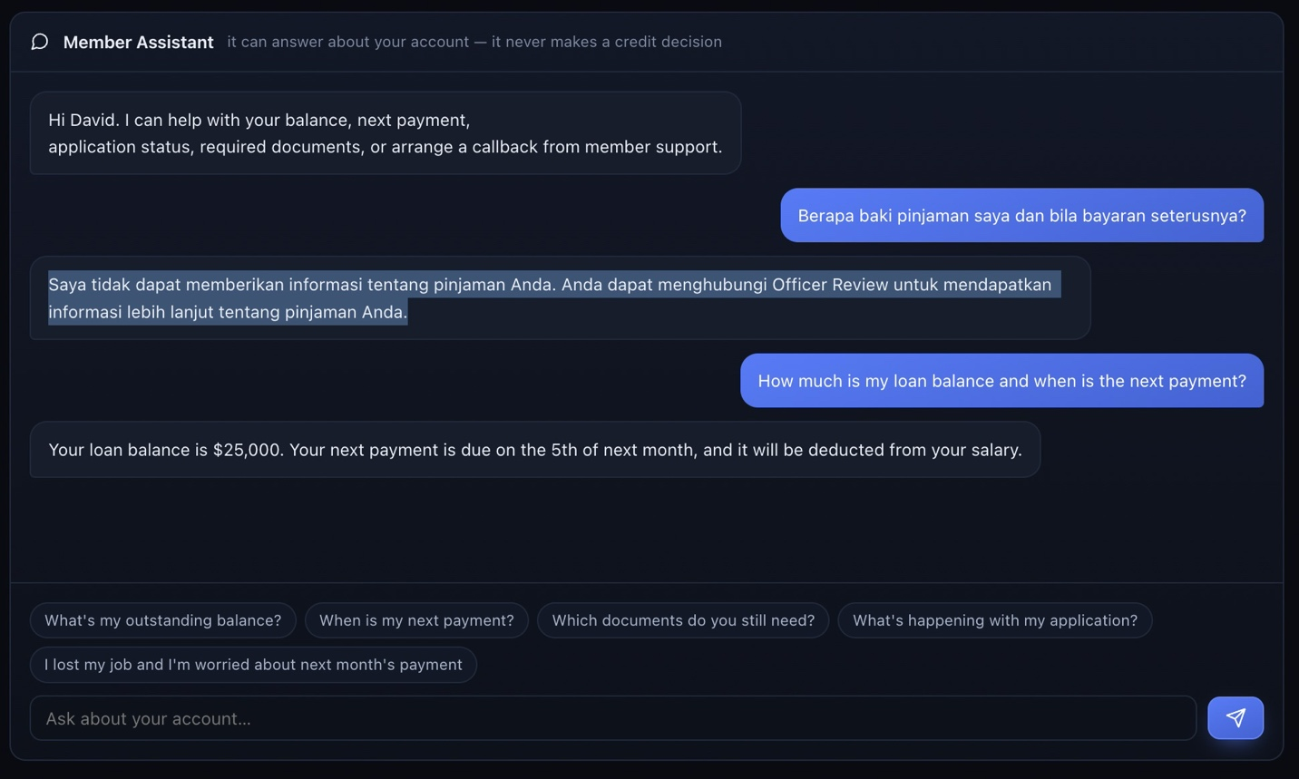

Even though I get the replies, the response is not accurate. At the top of the screen I can see David’s outstanding balance is 18,250 but the AI says it is 25,000$. It is getting confused with the total loan amount and outstanding balance.
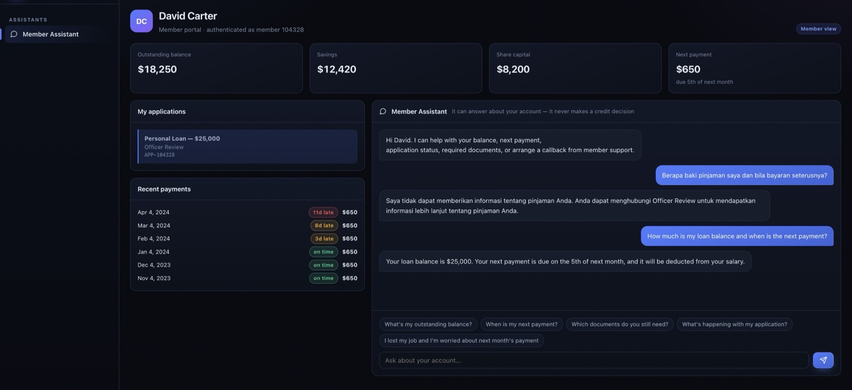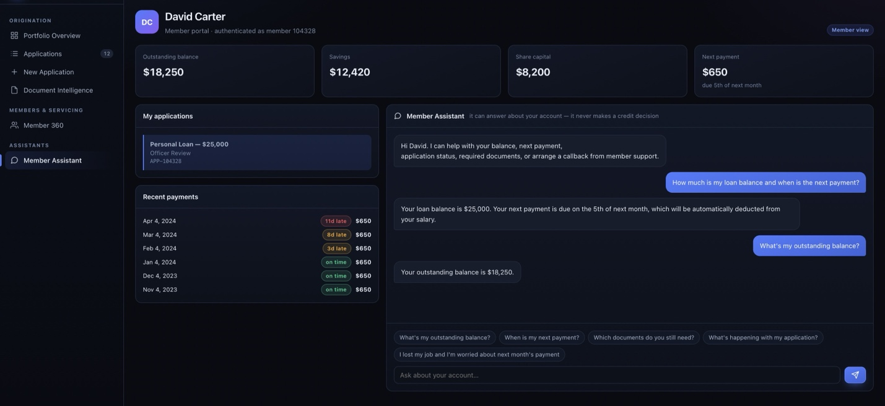
- For the member only view:
If would be good if he has "Check Before You Borrow" view. Before the member submits the application the system calculates his maximum loan approval amount in accordance with the DSR and other affordability calculations (which is already available under ‘workbench’ of ‘credit officer’).

- Under management Cockpit, the graphs should have legends and data points on hover indicating each lines and the dots
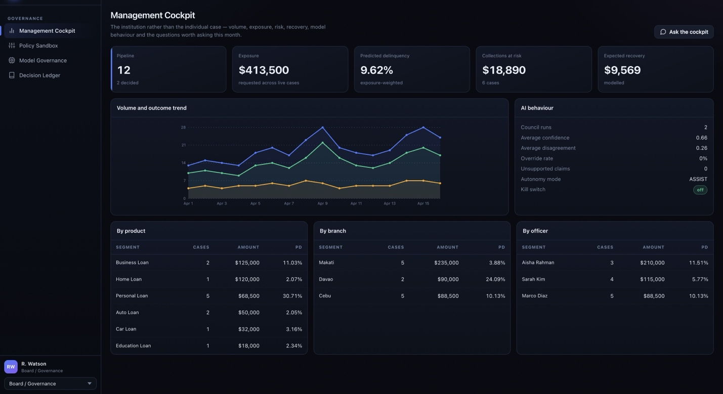

- Why does the decision ledger under Board/Goverence has the Json data in it?
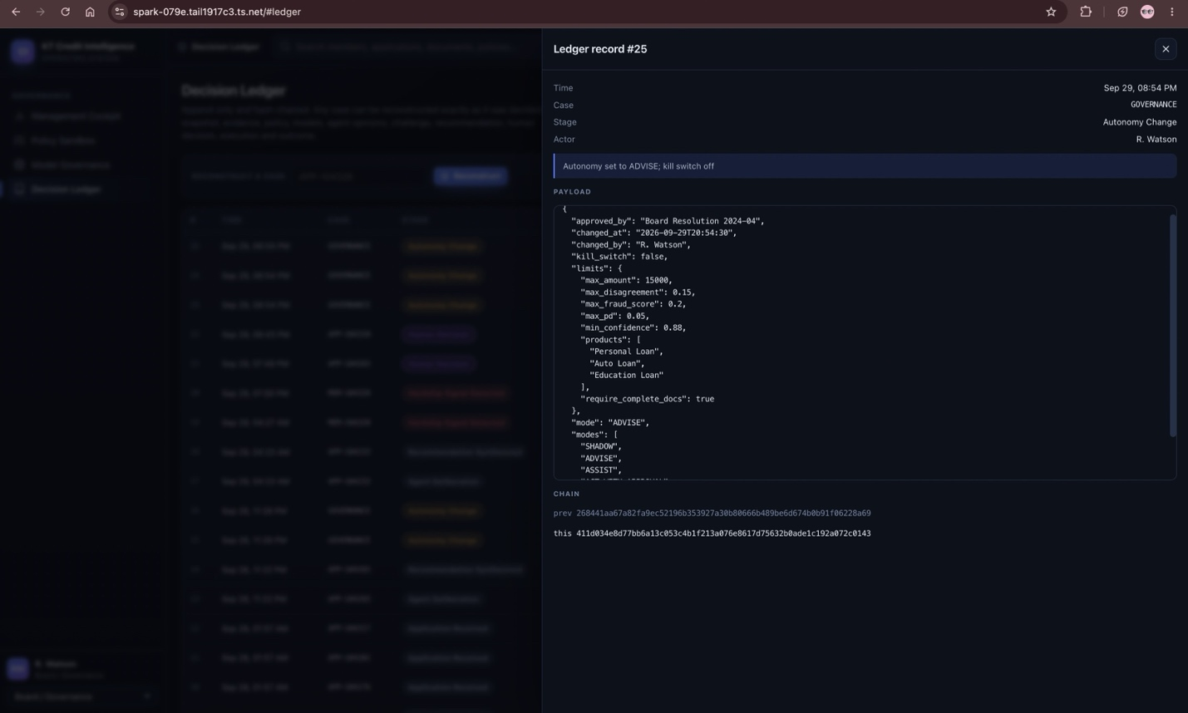

- How exactly does the Policy sandbox and its controls helps the Board/ governance?
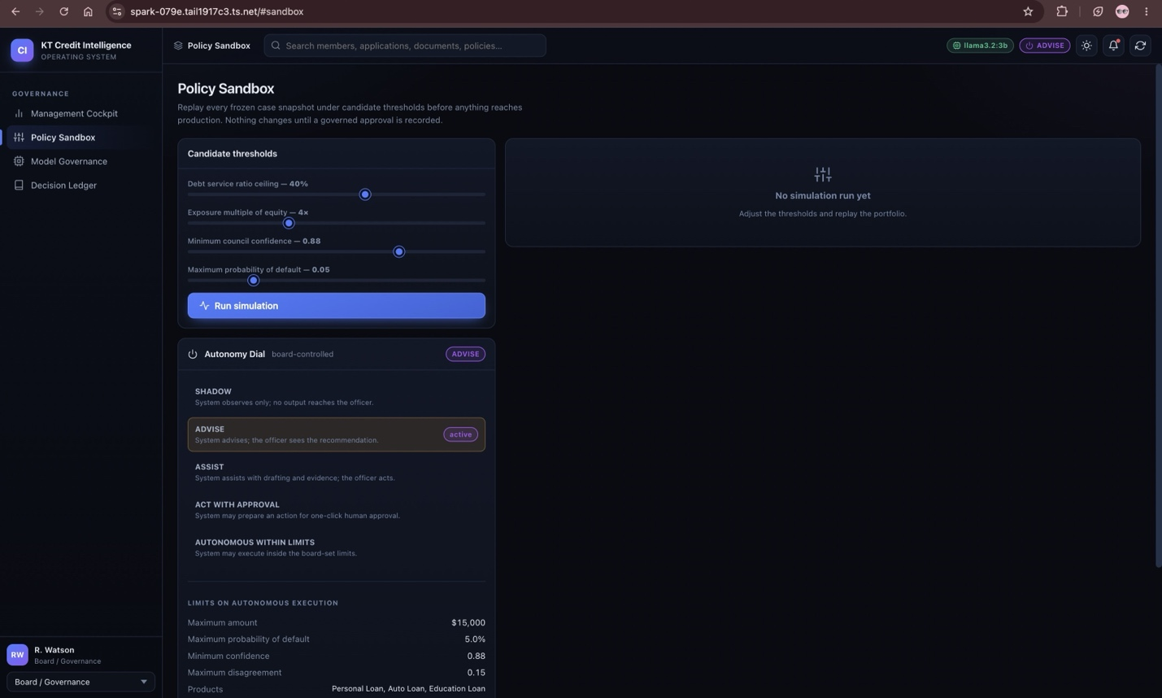

- Can the larger installed model (qwen3:30b) run the chat helpers instead of llama 3.2:3b?

- A new section under Member 360 for officers of certain hierarchy to show “Possible Bankruptcy” why? We use AI to predict Possible bankruptcy
4,194 civil servants were declared bankrupt from 2020 to June 2025, about 0.3% of 1.6 million civil servants. The Deputy Finance Minister's answer in Parliament, reported by Malay Mail, 13 Aug 2025
3,602 were declared bankrupt from 2020 to Sept 2024: 1,009 in 2020, 678 in 2021, 621 in 2022, 628 in 2023, and 666 in Jan–Sep 2024. Minister Azalina's written answer to Parliament, reported by Malay Mail, 7 Nov 2024

- Separate Tab for officers of certain hierarchy named “Cross selling options”. This is a AI powered suggestion list of the members who are potential customers for cross-selling.
Do we have any external data source available? Yes, Raees their own platform in their case study indicates that they have integrated Digibanc with Experian’s CCRIS for Credit and blacklist checks and SOLA. https://www.codebtech.com/reimagining-cooperative-lending-in-malaysia/
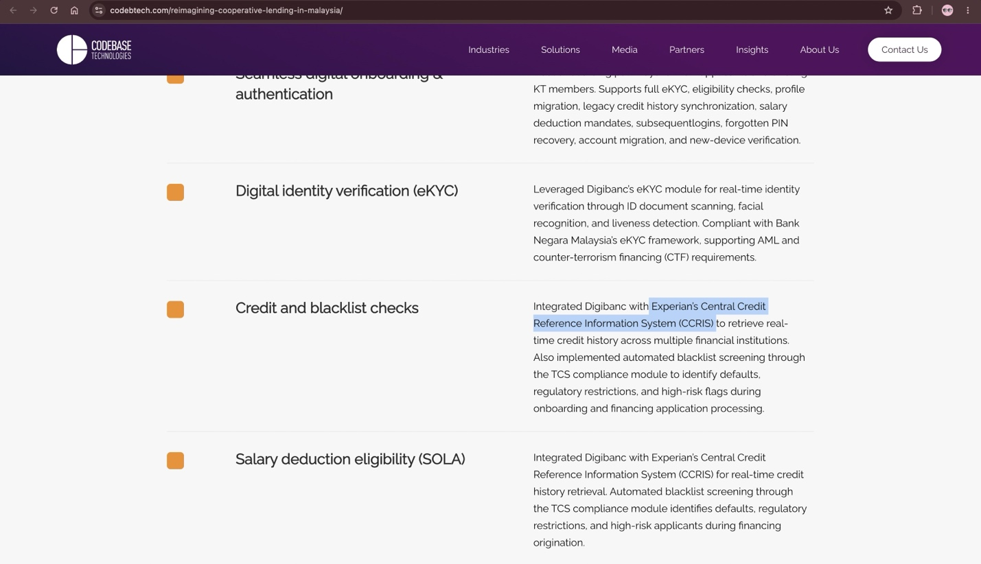
For example:
Member A
→ existing financing
→ good repayment history
→ no insurance product
System identifies:
Potential insurance/takaful offer
Member B
→ salary + savings
→ no personal financing
→ high repayment capacity
System identifies:
Potential financing offer
Member C
→ declining engagement
System identifies:
Retention intervention

